**Review 1**

**I.** Problem Definition**:**

“QuickLoan” is a company involved in providing loans to its customers. They have branches set up at different parts of the city. They cater to different types of loans like the vehicle loan, house loan, personal loan and loan to students higher studies.

Senior managers have decided to computerize the entire loan processing system and we have been given this task. The project has been named LPS (Loan Processing System).

**II.** Project objective**:**

Support “QuickLoan” in loan mangement. Include :

* User should accept the details of the customer like his address, organization, gross salary etc. and then process the loa
* The user should be able to choose the type of loan, loan amount, period and the branch from which the loan is asked.
* The system should then process the monthly installments based on the interest rates.
* The interest rates vary for different types of loans and the period. The system should also keep a track of the installments paid by the customer.
* The customer details would be stored in the system and user should be allowed to edit only the profile.

**1/ STAFF :**

* Customers details.
* Creat new request.
* Send a valid request to managers.
* View request status (pending/declined/approved)
* Search and view customers profile, contract details.
* Update customers profile
* Theo dõi các hợp đồng trễ hạn thanh toán.
* Thay đổi thông tin cá nhân.

**2/ MANAGER :**

* Search and view customers profile.
* Search and view contract details.
* Accept request of customers.
* Create, delete , update Fine.
* Create, delete , update loan.
* Update profile.

**3/ ADMIN :**

* Create, delete , update Member.
* Create, delete , update phân quyền tài khoản

**III.Software Requirements:**

**1.Hardware** :

a) Sever : (Recommended) :

* Intel ® Xeon ®/ Intel Pentium 3.0Ghz/3Mb Cache or higher
* Ram 4Gb or higher.
* HDD : 500Gb or higher.

b) Client : (Recommended) :

* Core Dual 2.0 GHz or higher.
* Ram 2Gb or higher.

**2.Software :**

* Java Virtual Machine
* Notepad/Java editor (Netbean 7.4 or newer)
* j2sdk1.4.1_02 (or newer).
* SQL Server 2012 (or newer).

**IV. Inputs provided by the application:**

1. **Employee :**

***Input :***

* Login info:

1. User ID.
2. Password.

* Customer profile:

1. Full Name.
2. Indentify Card.
3. Address.
4. Organization
5. Phone Number.
6. Gross Salary.

* Customer’s account number.
* Fine:

1. Code fine.
2. Find rate (%).

* Request :

1. Account Number.
2. Loan Type.
3. Loan Amount
4. Grade
5. Period

**Progress :**

* Store customer details in database.
* Create new request.
* Send pending request to manager.
* Collect customer’s monthly installment and fine.
* Change password, customer profile.

- Keep a track of the installments paid by the customer.

**Output :**

* Customer’s details.
* Contract details (Request after would be approved ).
* View status of requests (pending, approved,declined)
* View late term contract which failing pre decided date.
  + Track of the installments paid by the customer.

1. **Manager :**

***Input :***

* Login info..
* Account number, Contract ID
* Loan type:

1. Type name.
2. Intersest Rate (%).

* Grade

1. Grade ID
2. Gross salary
3. Collateral
4. Max amount
5. Min period
6. Max period

***Progress :***

* Decide request status.
* Change password, personal profile.

***Output :***

* List of customer details.
* List of request.
* List of loan type.
* List of grade.

1. **Administrator :**

**Input:**

* Login info.
* User info.

1. Login ID.
2. Password.
3. Role.
4. Full name.

* Role info:

1. Code role.
2. Description

***Progress :***

* Insert , delete employee, manager.
* Insert , edit, delete roles.
* Change personal profile.

***Output :***

* List of employee, manager.
* List of role.

**V. Function Diagrams:**

**1.Employee :**



**2.Manager :**



**3.Administrator :**



**VI. Task Sheet:**

|  |  |  |  |  |  |
| --- | --- | --- | --- | --- | --- |
| Member | | Timeline | | | |
| NO | Full Name | Task | Start Date | Date Finish | Status |
| 1 | Phạm Minh Lập (Leader) | Cùng làm | 02/08/2014 | 04/08/2014 | Hoàn Thành |
| 2 | Trương Ngọc Đăng Khoa | Cùng làm | 02/08/2014 | 04/08/2014 | Hoàn Thành |
| 3 | Trần Hữu Trí | Cùng làm | 02/08/2014 | 04/08/2014 | Hoàn Thành |
| Instructor | | | Leader | | |
|  | | |  | | |
| Lê Mộng Thúy | | | Phạm Minh Lập | | |

**Review 2**

**VII Cơ sở dữ liệu :**

**1.Entities- Attributes:**





















**2.Table :**

Table tbRole :

|  |  |  |  |
| --- | --- | --- | --- |
| Column Name | Kiểu dữ liệu | Đặc điểm | Giải thích |
| Role_ID | Tinyint | Indentity(1,1) | Code Role |
| Description | nVarchar(20) | Not null | Role Name |

Table tbUser:

|  |  |  |  |
| --- | --- | --- | --- |
| Column Name | Data Type | Constraints | Description |
| user | Varchar(16) | Primary | Login user |
| password | Varchar(20) | Not null | Password |
| role | Tinyint | Foreign key | Code Role |
| fullname | nVarchar(30) | Not null | Full Name |

Table tbLoanType

|  |  |  |  |
| --- | --- | --- | --- |
| Column Name | Data Type | Constraints | Description |
| loanName | nVarchar(20) | primary | Loan Name |
| rate | Tinyint | Not null | Interest Rate(%) |

Table tbFine:

|  |  |  |  |
| --- | --- | --- | --- |
| Column Name | Data Type | Constraints | Description |
| fineID | Tinyint | Primary | Code Fine |
| InterestRate | Tinyint | Not null | Fine Rate(%) |
| from | Int | Not null | Condition |
| to | Int | Not null | Condition |

Table tbCustomerDetails

|  |  |  |  |
| --- | --- | --- | --- |
| Column Name | Data Type | Constraints | Description |
| accountNo | int | Indentity | Account Number |
| name | nVarchar(30) | Not null | Customer Name |
| indentifyCard | Varchar(15) | Not null | Indentify Card |
| address | nVarchar(50) | Not null | Customer Address |
| orangization | nVarchar(50) | Not null | Customer Orangization |
| phone | Varchar(11) | Not null | Customer Phone |
| Dob | Date | Not null | Date of Birth |
| grossSalary | Int | Not null | Customer Gross Salary |

Table tbPaymentDetails:

|  |  |  |  |
| --- | --- | --- | --- |
| Column Name | Data Type | Constraints | Description |
| contractID | int | Indentity | Code Contract |
| accountNo | int | Foreign key | Account Number |
| loanType | money | Foreign key | Loan Type |
| collateral | money | Not null | Collateral |
| grade | char(1) | Foreign key | Loan Grade |
| period | tinyint | Not null | Loan Period |
| status | nVarchar(10) | Not null | Request Status |
| paid | nVarchar(15) | null | Monthly Payment Status |

Table tbGrade:

|  |  |  |  |
| --- | --- | --- | --- |
| Column Name | Data Type | Constraints | Description |
| gradeID | Char(1) | Primary | Code grade |
| grossSalary | Money | Not null | Gross salary |
| collateral | Money | Not null | Collateral |
| maxAmount | Money | Not null | Maximum Amount |
| minPeriod | Tinyint | Not null | Minimum Period |
| maxPeriod | Tinyint | Not null | Maximum Period |

Table tbPaymentDetails:

|  |  |  |  |
| --- | --- | --- | --- |
| Column Name | Data Type | Constraints | Description |
| contractID | Int | Foreign Key, primary | Code contract |
| Month | Tinyint | Primary | Month |
| principal | Money | Not null | Principal |
| bgDate | Date | Not null | Begin contract |
| paymentDate | Date | Not null | Monthly payment date |
| currentDate | Date | Not null | Current Date |
| paymentStatus | nVarchar(10) | Null | Payment Status |
| remaining | money | Not null | Remaining Amount |
| total | money | Not null | Total Amount |
| interest | money | Not null | Interest Amount |

**3.Database Diagrams :**



**IX. Task Sheet:**

|  |  |  |  |  |  |
| --- | --- | --- | --- | --- | --- |
| Member | | Timeline | | | |
| NO | Full Name | Task | Start Date | Date Finish | Status |
| 1 | Phạm Minh Lập (Leader) | Cùng làm | 04/08/2014 | 10/08/2014 | Hoàn Thành |
| 2 | Trương Ngọc Đăng Khoa | Cùng làm | 04/08/2014 | 10/08/2014 | Hoàn Thành |
| 3 | Trần Hữu Trí | Cùng làm | 04/08/2014 | 10/08/2014 | Hoàn Thành |
|  |  |  |  |  |  |
| Instructor | | | Leader | | |
|  | | |  | | |
| Lê Mộng Thúy | | | Phạm Minh Lập | | |

**Review 3**

**Interface Design**

1. **Login**

When you open the application, the login diablog will be show up allow user to login to the system.

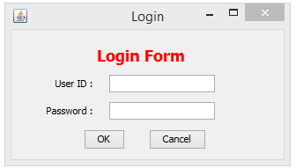

When user enter with invalid username or invalid password. Error message will be show.

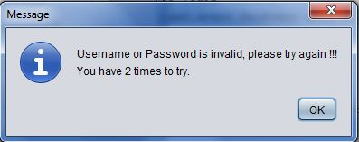

1. **Employee Home**

If the user is normal employee, the application will show the employee interface. Staff Home:

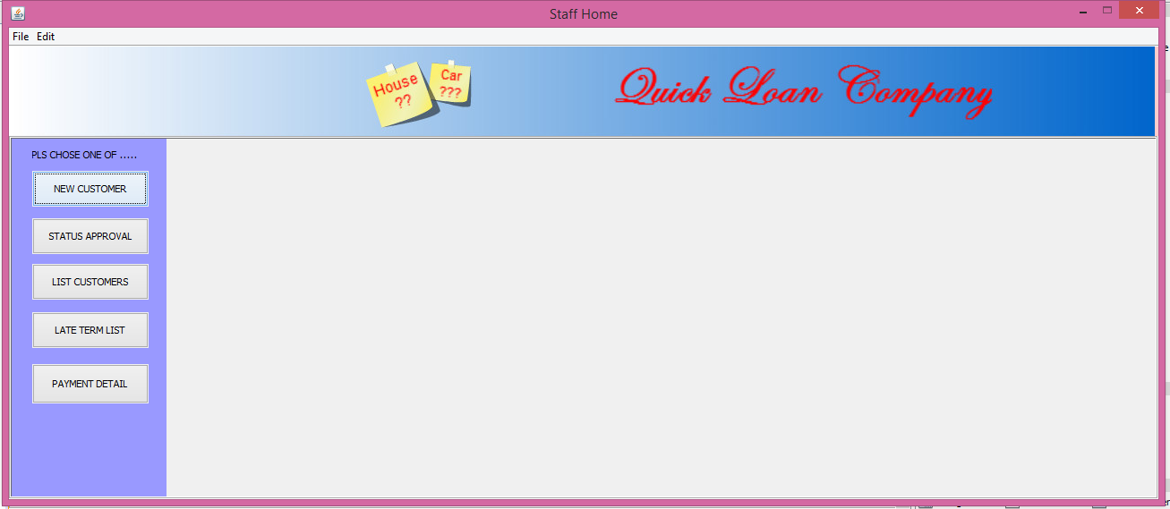

Button “New Customer” 🡪 Move to “Check Grade” tab

* 1. **In “Check Grade” Tab:**

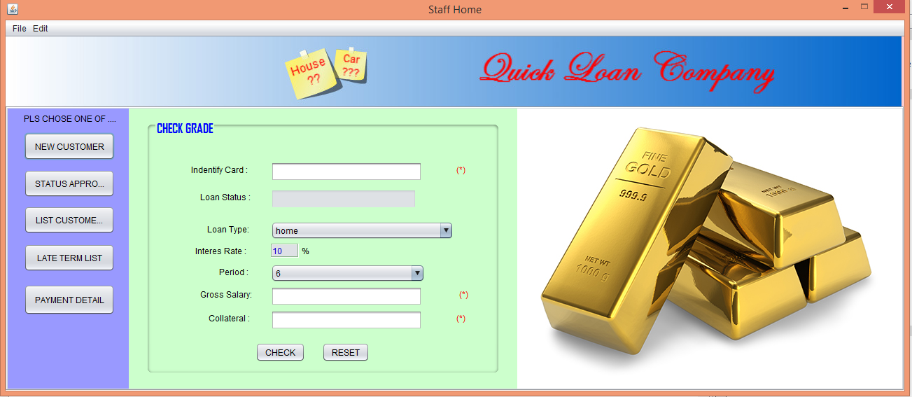

User can input customer’s “Indentity Card” then if the customer who had some loan in progress of payment ,the “Loan Status” would be displayed the amount of customer’s loan.

Then the user can choose “Loan Type”,”Period” and input “Gross Salary”, “Collateral” to check the “Grade” which will be based on those info above to calculate the maximum loan amount the customer can be request.

After then, if user press the button ”Check”, the “Result” tab will be displayed to show information about “Grade”, “Max Loan”, “Min period”,”Max Period”:

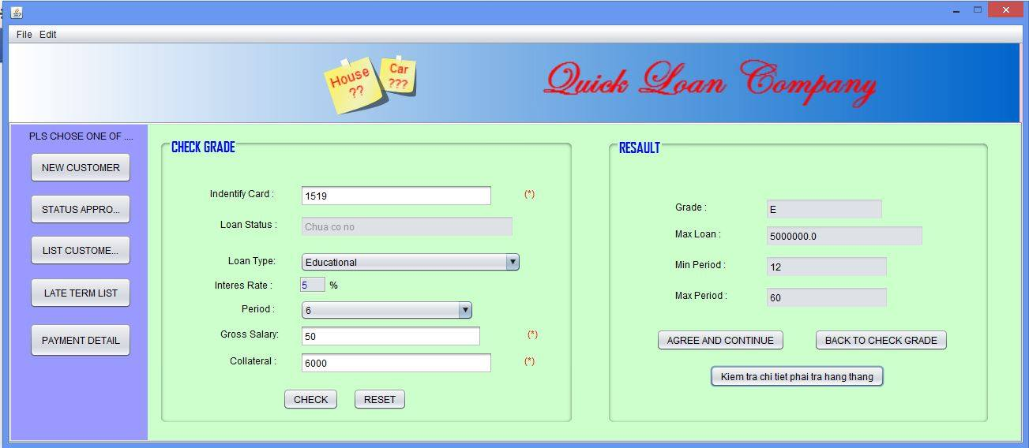

* **Button “Back to check grade” 🡪** Allow user can refill fields on “Check grade” tab.
* **Button “Check Installment” 🡪 Open dialog “Check Installment” :** this will help the user to calculate monthly installment then show it to the customer.

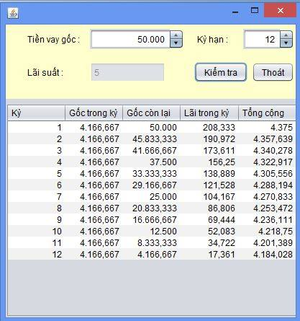

* Button “Check” 🡪 Display monthly installment details on the table.
* Button “Exit” 🡪 Close dialog
* **Button “Agreed and continue” 🡪 Move to ”New Contract” tab**

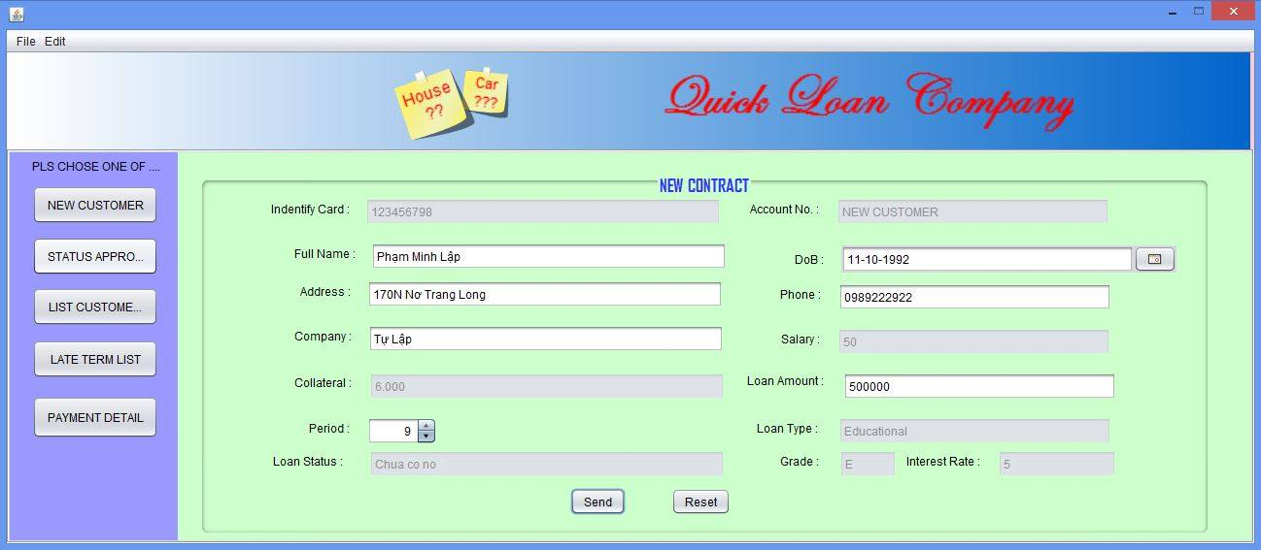

* If the customer existed , the customer’s information fields auto fill.
* Button “Send” 🡪 Send the request with pending status.
  1. **In “Status Approved” tab:**

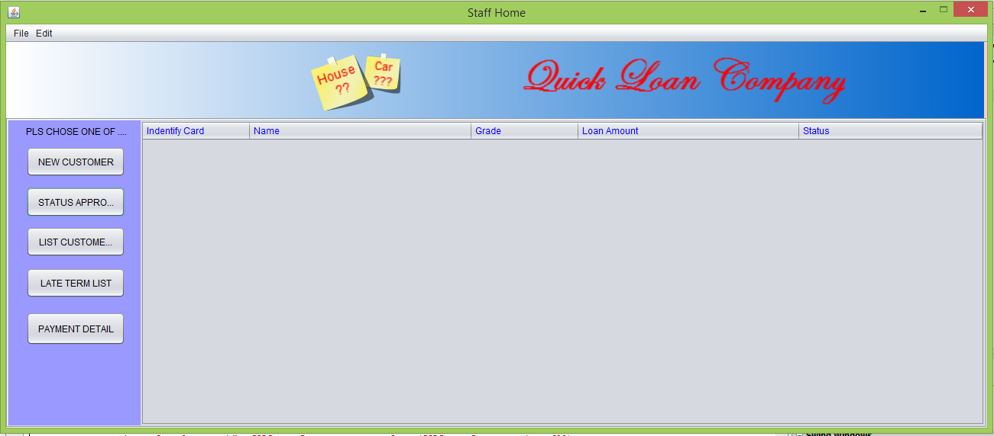

User can view the “Request” and it’s status (Pending/Approved/Decided)

* 1. **In “List of Customer”**

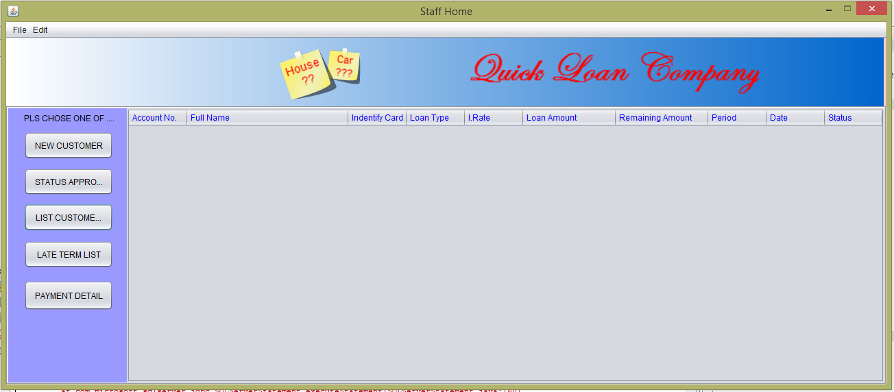

User can info about customer and can change’s customer personal info.

* 1. **In “Payment Details” tab**

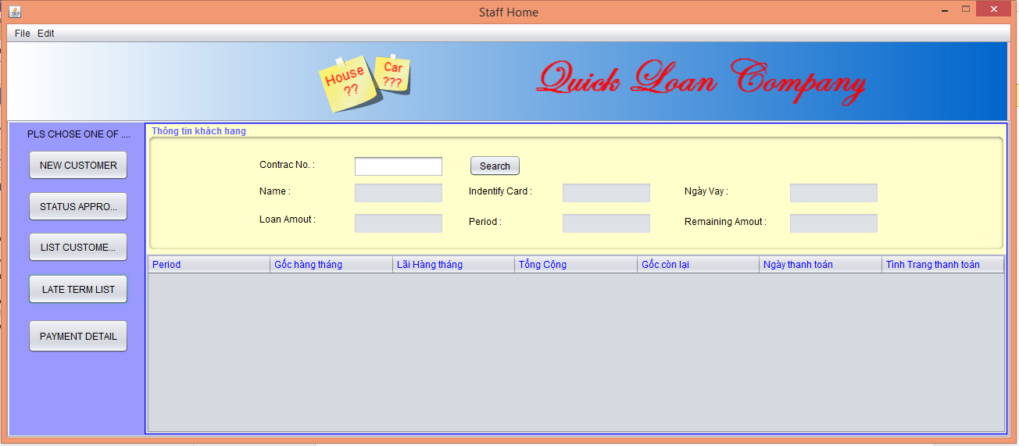

User can track of loan’s payment details of customer

1. **Manager**

If the user is manager, the application will show the manager interface. Manager Home

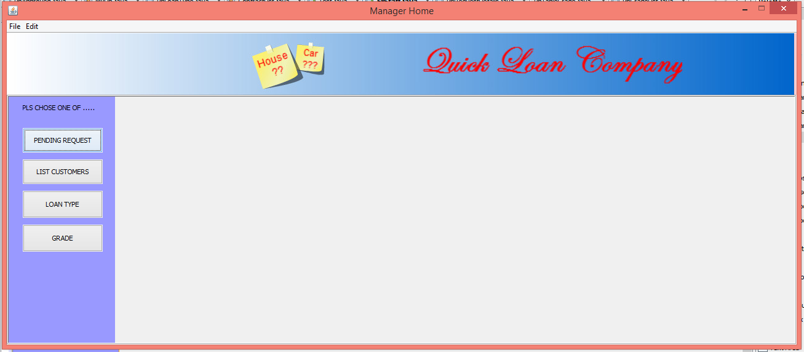

* Button “Pending Request”🡪 Move to “Pending Request” tab.
* Button “List of Customer” 🡪 Move to “List customer” tab.
* Button “Loan Type” 🡪 Move to “Loan Type” tab.
* Button “Grade” 🡪 Move to “Grade” tab.
  1. **In “Pending Request” tab:**

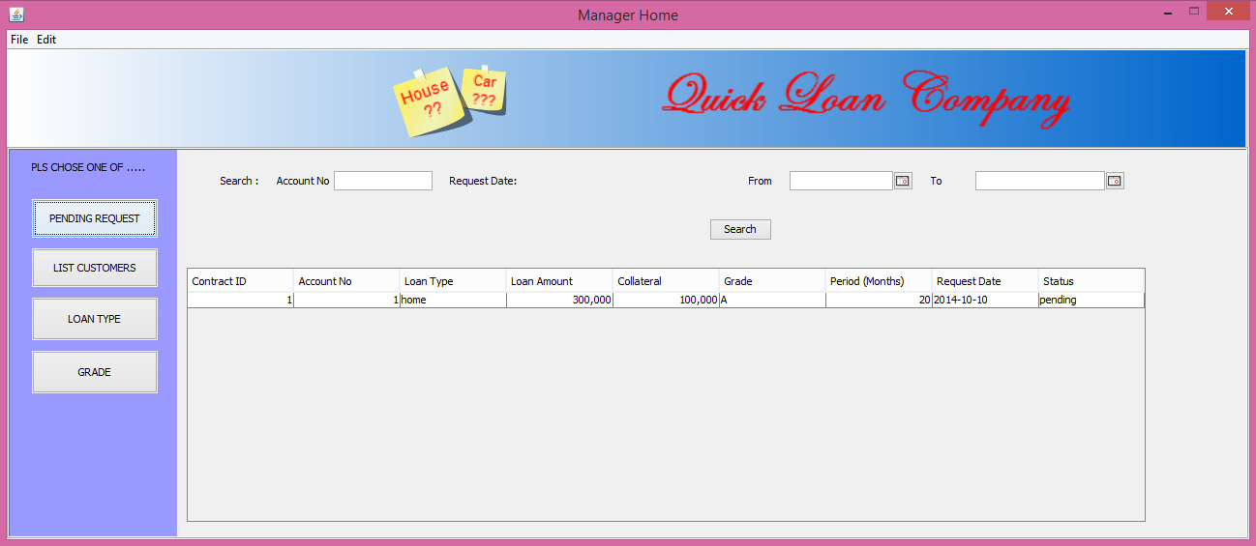

* User can view all of “Request”
* User can search “Request” by “Account Number” or by “Request Date”
* When user double click on any “Request” on the list. A new form which will display details about the “Request” in a dialog:

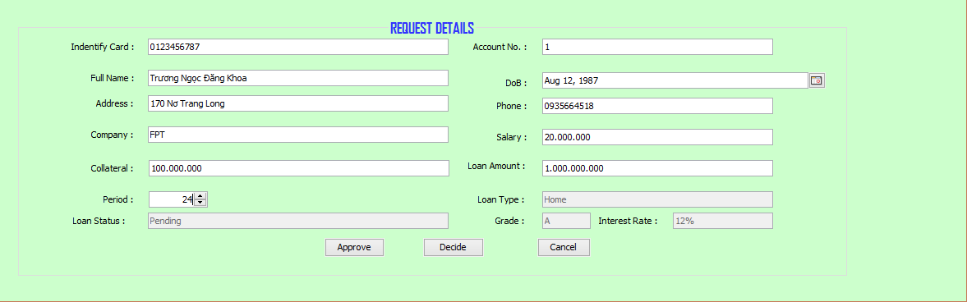

* When click button “Approve” :

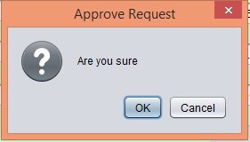

* + Button “OK”🡪 Request Status will change to “Approved”.
  + Button “Cancel” 🡪 Cancel the action.
* When click button “Decline”:

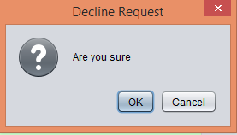

* + Button “OK”🡪 Request Status will change to “Declined”.
  + Button “Cancel” 🡪 Cancel the action.
* When click “Cancel” 🡪 Move to “Home” tab
  1. **In “Loan Type” Tab:**

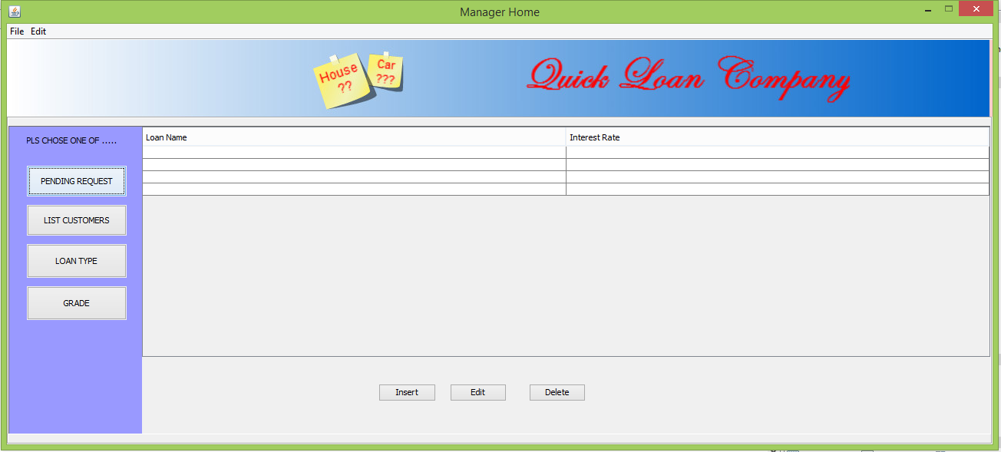

* When click button “Insert” 🡪 Open to “Loan Type Insert” tab in a dialog:

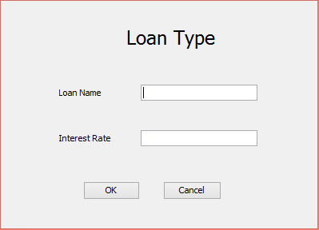

* + When click”OK”. If “Loan Name” exsisted in database, a alert dialog would display.

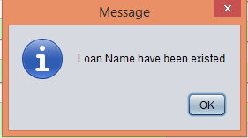

* Else:

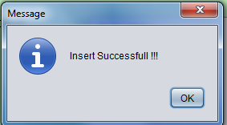

* When click ”Delete” 🡪 A dialog will be display :

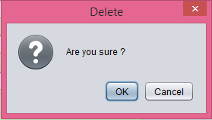

* Button “OK” 🡪 The Loan Type will be deleted.
* Button “Cancel” 🡪 Cancel the action.
  1. **In “Grade” Tab:**

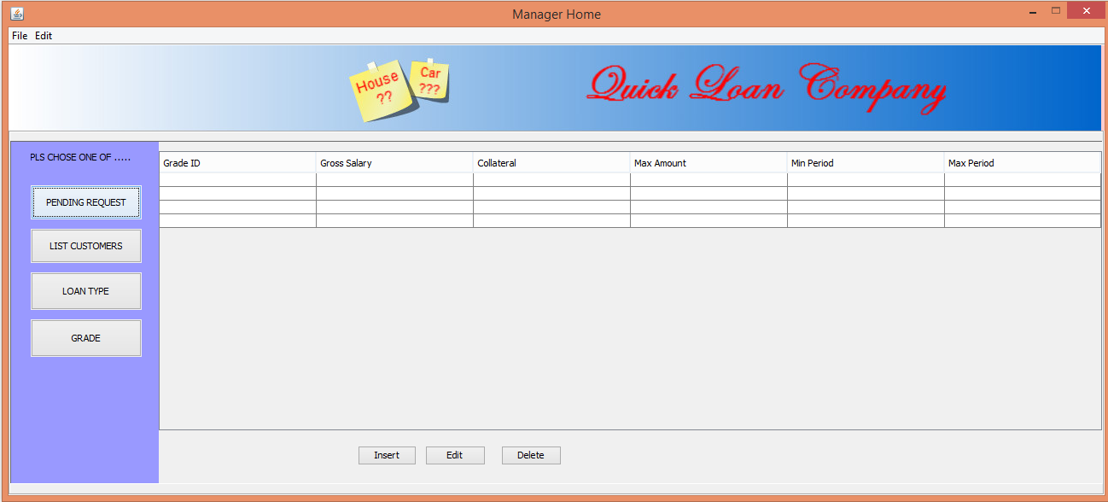

* When click buttom “Insert”🡪 Open a insert form dialog:

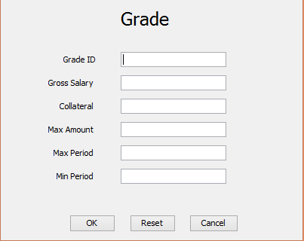

* + Button “OK”. If “Grade ID” exsisted in database, a alert dialog would display.

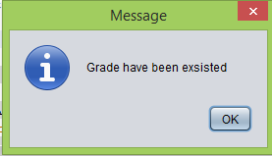

* + Else



* + Button “Reset” 🡪 Clear all fields.
  + Button “Cancel” 🡪 Cancel action.
  1. **“Customer Details” tab is the same as normal employee user.**

**XII.Task Sheet:**

|  |  |  |  |  |  |
| --- | --- | --- | --- | --- | --- |
| Member | | Timeline | | | |
| NO | Full Name | Task | Start Date | Date Finish | Status |
| 1 | Phạm Minh Lập (Leader) |  |  |  | Hoàn Thành |
| 2 | Trương Ngọc Đăng Khoa |  |  |  | Hoàn Thành |
| 3 | Trần Hữu Trí |  |  |  | Hoàn Thành |
| Instructor | | | Leader | | |
|  | | |  | | |
| Lê Mộng Thúy | | | Phạm Minh Lập | | |